B. Security Testing
1.
Tools of security testing for Warehouse Inventory System:
The warehouse inventory system(WIS) is a web application in PHP localhost. Zed Attack Proxy (ZAP) is the most suitable tool for security testing in warehouse inventory systems because it was developed for security testing web applications.
- ZAP is a free, open-source testing tool.
- ZAP is perfect for new security testing testers because of its easy-to-use interface.
- It can manually and automatically scan the system for risks.
- Users may install ZAP into the development process to automatically scan the system for security vulnerabilities as it is being constructed.

Types of security testing for Warehouse Inventory System:

Input Validation Testing:
Ensures that the WIS system correctly verifies all user input (e.g., adding products or quantity) to prevent malicious data from attackers.
Authentication Testing:
Brute Force Protection: Checks if the WIS system limits repeated failed login attempts to prevent attackers from guessing passwords.
Password Policies: Ensure users create strong passwords.
Session Management Testing:
Session Expiration: Verifies that user sessions terminate correctly after logout, ensuring no one can access open sessions later.
Session Timeout: Verifies inactive sessions log out automatically to prevent unauthorized access.
Session Hijacking: Ensures user logged in, such as admin sessions are secured to stop session data from being stolen.
Vulnerabilities Assessment:
SQL Injection: Verifies that an attacker may access or change the database by entering malicious commands through forms.
Cross-Site Scripting (XSS): Prevents unauthorized scripts from being inserted into system that may harm users or the WIS system. It ensures that all user inputs are cleaned appropriately.
Cross-Site Request Forgery (CSRF) Testing: Checks that wrong operations, including deleting inventory items, cannot be carried out by misleading a registered user. It determines whether the WIS system protects essential functions with CSRF tokens.
Security Headers Testing:
X-Frame-Options: The WIS system is protected from unwanted clicking by being embedded on other websites.
Content Security Policy (CSP): Minimizes the threat of malware executing by allowing only verified programs and data.
HSTS (HTTPS): Checks for secure connections when the WIS system goes live or runs on localhost.
2. Security Testing for Warehouse Inventory System
Project: PHP-Based Warehouse Inventory System
The warehouse inventory system allows users (e.g., warehouse managers) to perform actions such as:
- Logging in.
- Adding new inventory items (e.g., products, quantities).
- Adding existing items (e.g., sales or category).
- Deleting outdated or unwanted items.
Security Testing Example Using OWASP ZAP:
- Set Up OWASP ZAP: Install OWASP ZAP on the system.
- Start the Inventory System: Launch the warehouse inventory system on localhost ( http://localhost/warehouse-inventory-system-master/home.php# ).
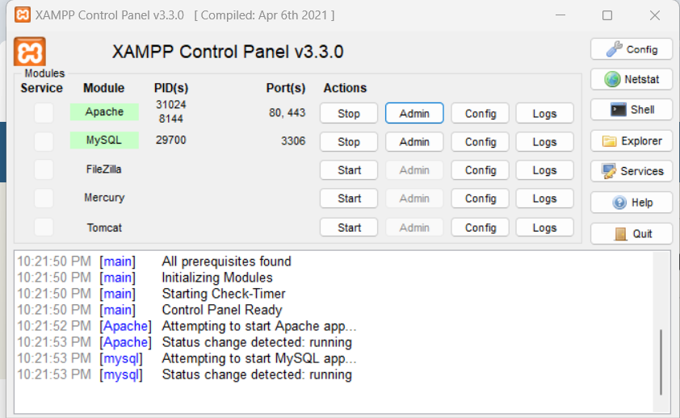

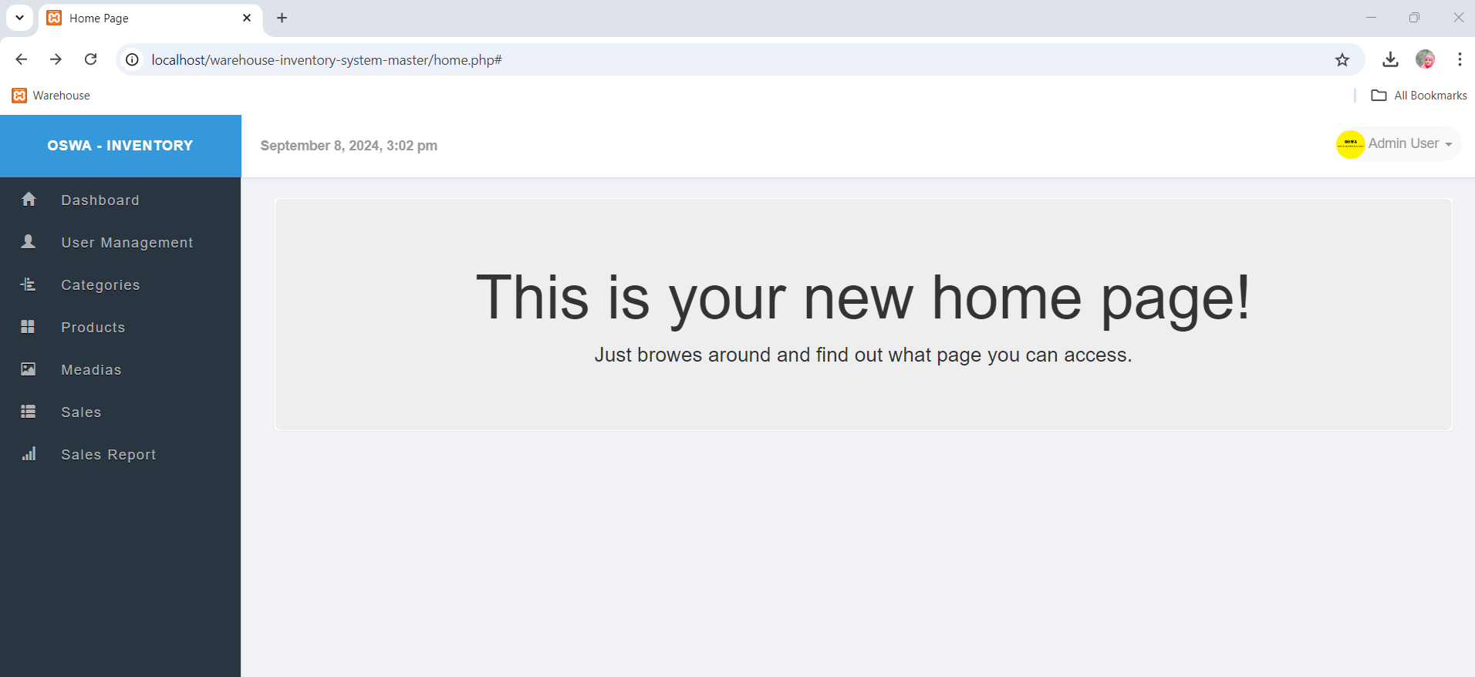

- Run Basic Security Scans in ZAP
Automated Scan :
- URL to attack: http://localhost/warehouse-inventory-system-master/home.php#.
- Use Ajax Spider with : Chrome headless
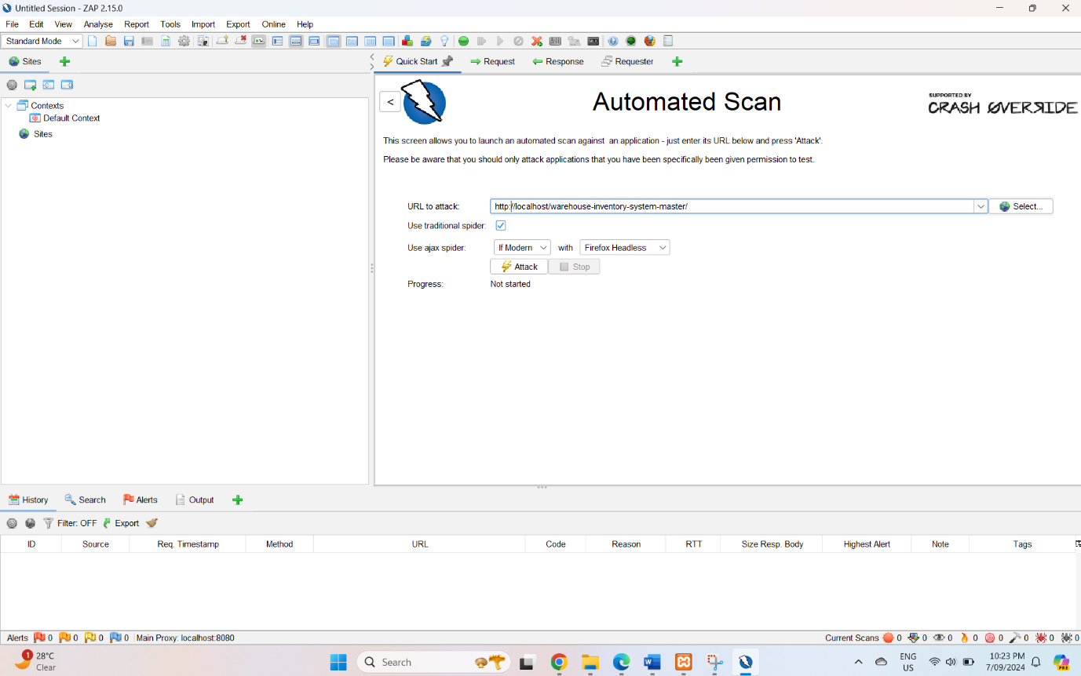
- Attack.
- Start an automated scan to check for vulnerabilities.
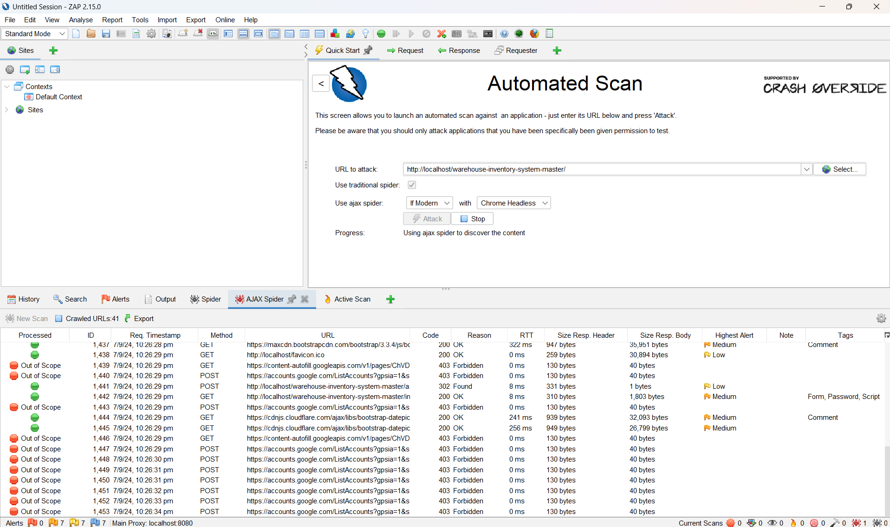
- View and Analyze Results: ZAP lists alerts (21) found in the WIS system after scanning.
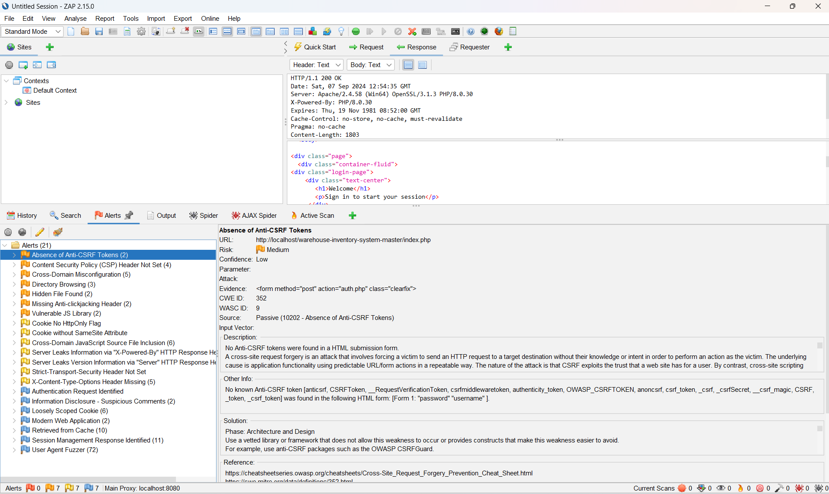
- High Priority: 0
- Medium Priority: 7
- Absence of Anti-CSRF Tokens (2)
- Content Security Policy (CSP) Header Not Set (4)
- Cross-Domain Misconfiguration (5)
- Directory Browsing (3)
- Hidden File Found (2)
- Missing Anti-clickjacking Header (2)
- Vulnerable JS Library (2)
- Low Priority: 7
- FU Cookie No HttpOnly Flag
- Cookie without SameSite Attribute
- Cross-Domain JavaScript Source File Inclusion (6)
- Server Leaks Information via "X-Powered-By" HTTP Response Header Field(s) (3)
- Server Leaks Version Information via "Server" HTTP Response Header Field (8)
- strict-Transport-Security Header Not Set
- X-Content-Type-Options Header Missing (5)
- Informational Priority: 7
- Authentication Request Identified
- Information Disclosure - Suspicious Comments (2)
- Loosely Scoped Cookie (3)
- Modern Web Application (3)
- Retrieved from Cache (12)
- Session Management Response Identified (6)
- User Agent Fuzzer (72)

